Ideation Phase
Empathize & Discover
Date | 27 September 2026
Team ID | SWTID-2026-7148
Project Name | AI Weatherwise API
Maximum Marks | 4 Marks

Empathy Map Canvas:
An empathy map is a simple visual tool used to understand a user’s behaviour, thoughts, feelings, goals, and challenges. It helps teams understand the user’s perspective and create a better solution.
Example:
Empathy Map
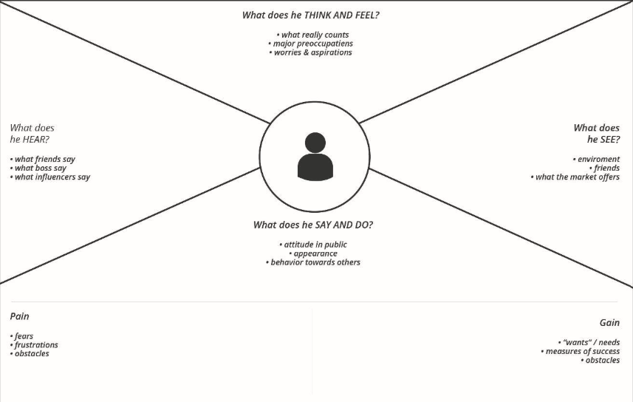

Example:

